Linux basics – 2
drwxrwxrwx
d- directory
rwx owner
rwx groups
rwx users
r – read- 4
w – write 2
x – execute 1
chmod It is used to modify or change access the file
for example chmod 777 techie, so that it will give all access to techie file
7 means 4+2+1
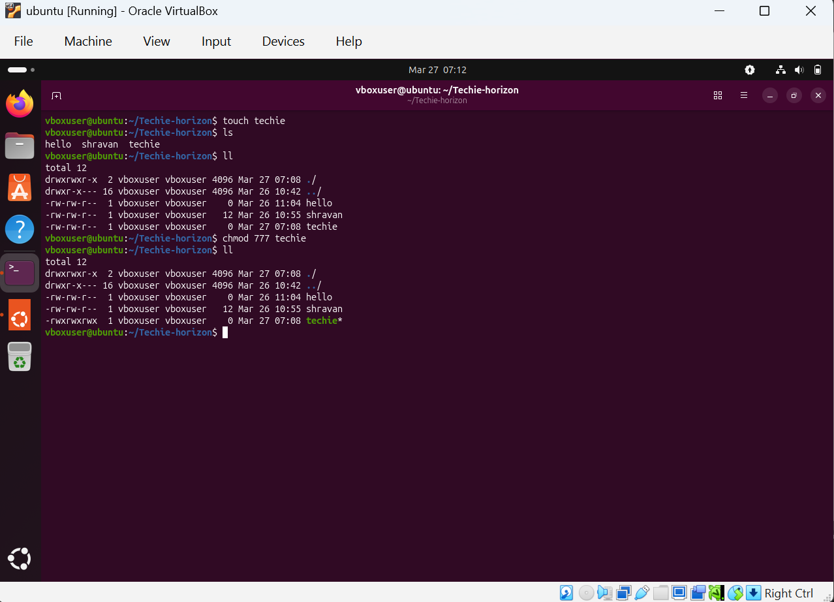
chmod 471 techie
means it will get only read access for users, read, write, execute for groups and execute for others
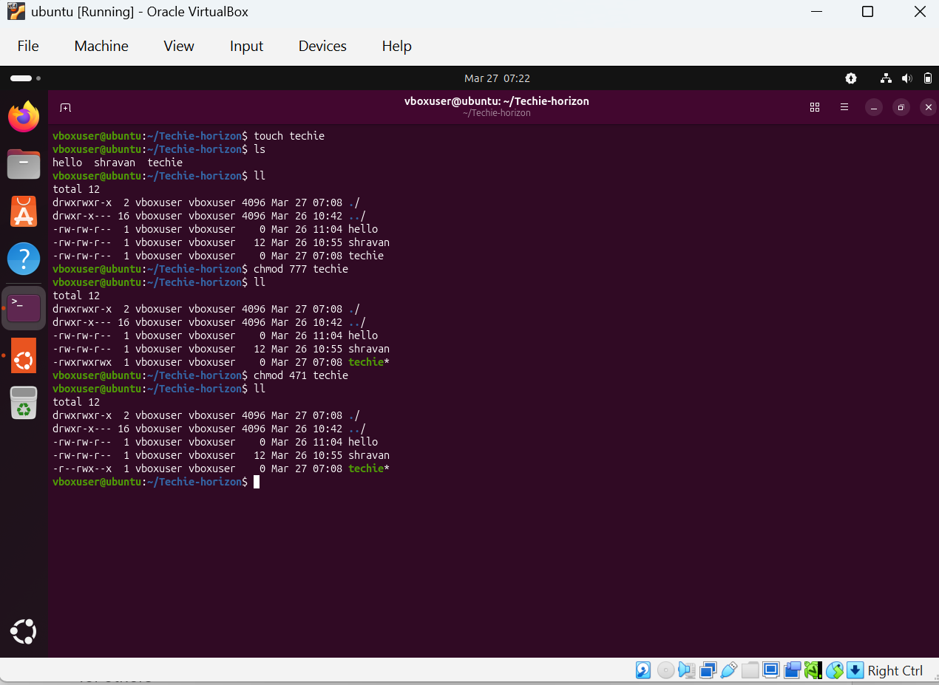
cat etc/passwd to check the list of users
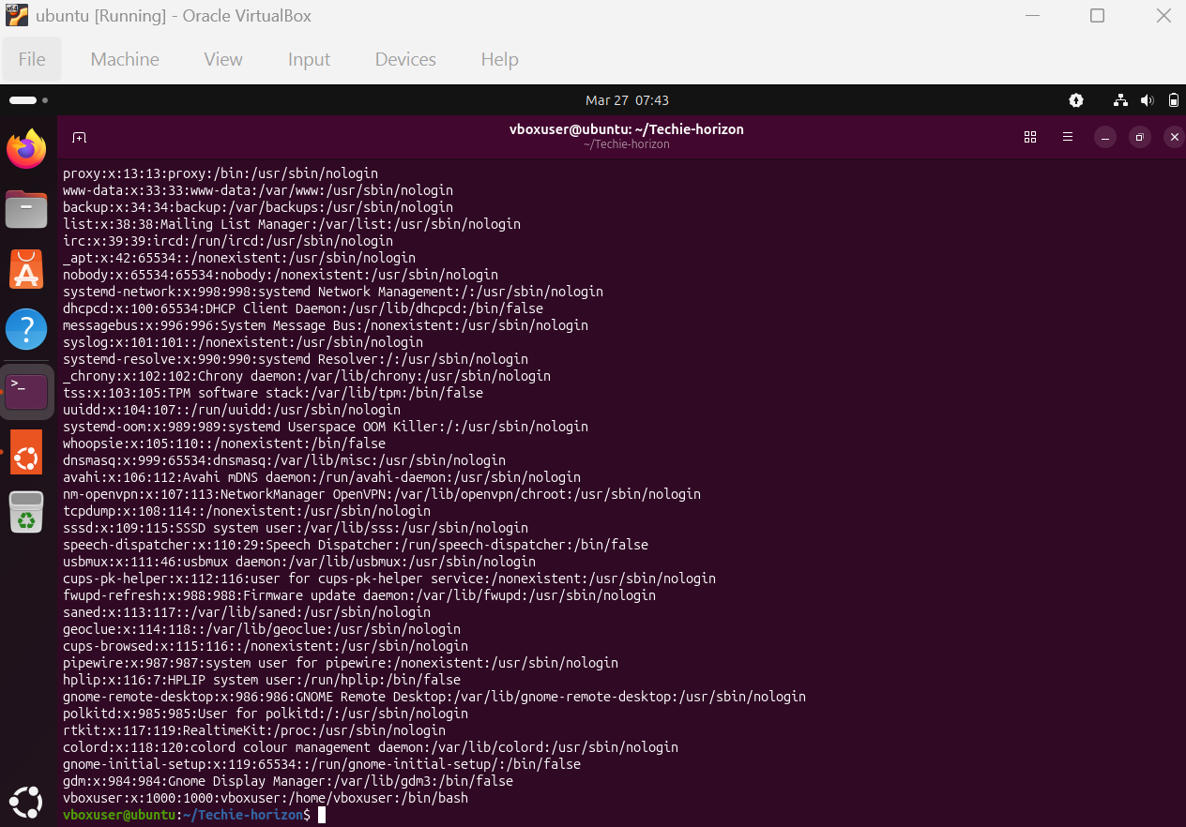
sudo chown to change the ownership
for example
sudo chown root:root techie
now from vboxuser it will change as root as user and group
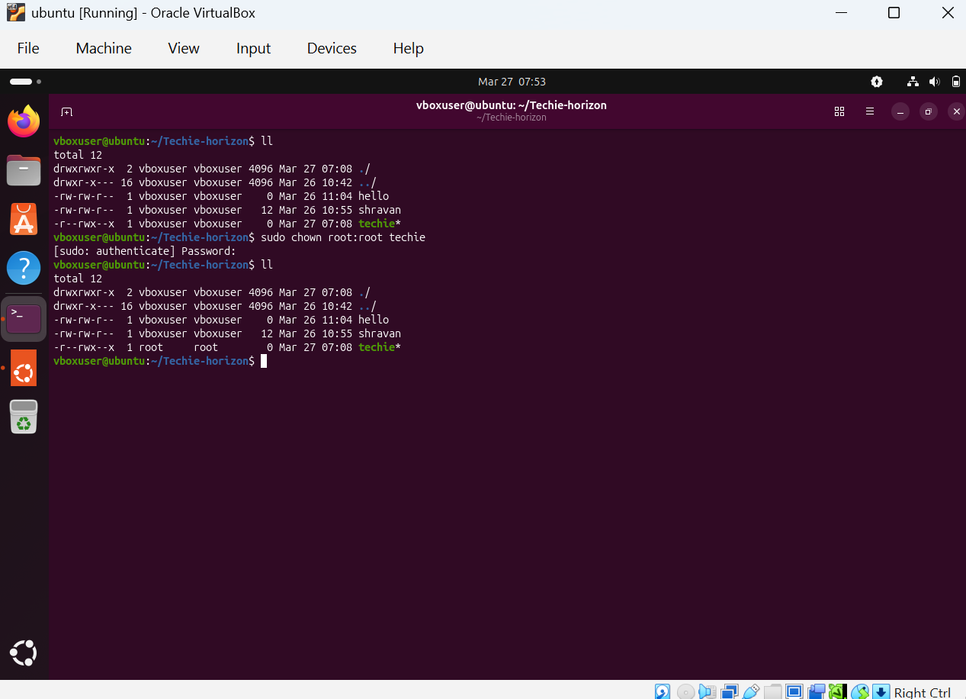
su root
to change any file into the user then we use su, it means s-switch u -user
now it will change it to root
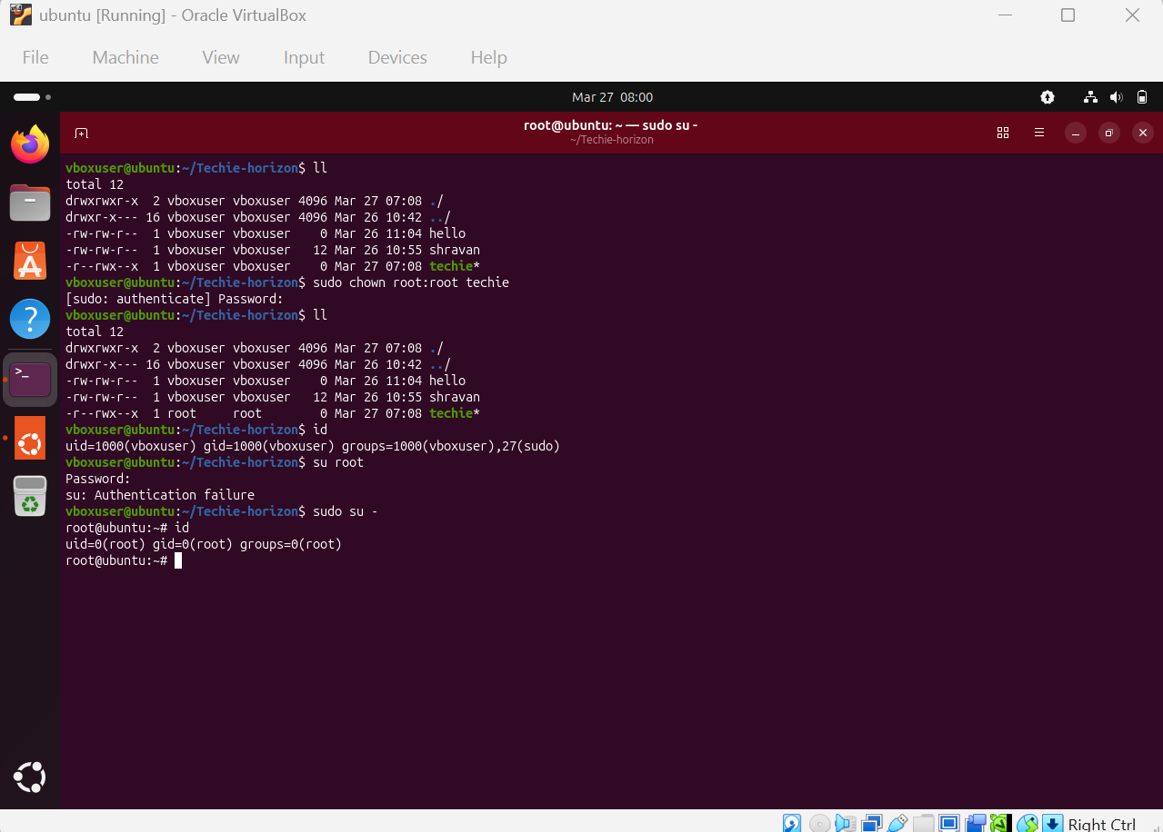
If it is not having then click sudo su –
useradd techie
it will add techie as user
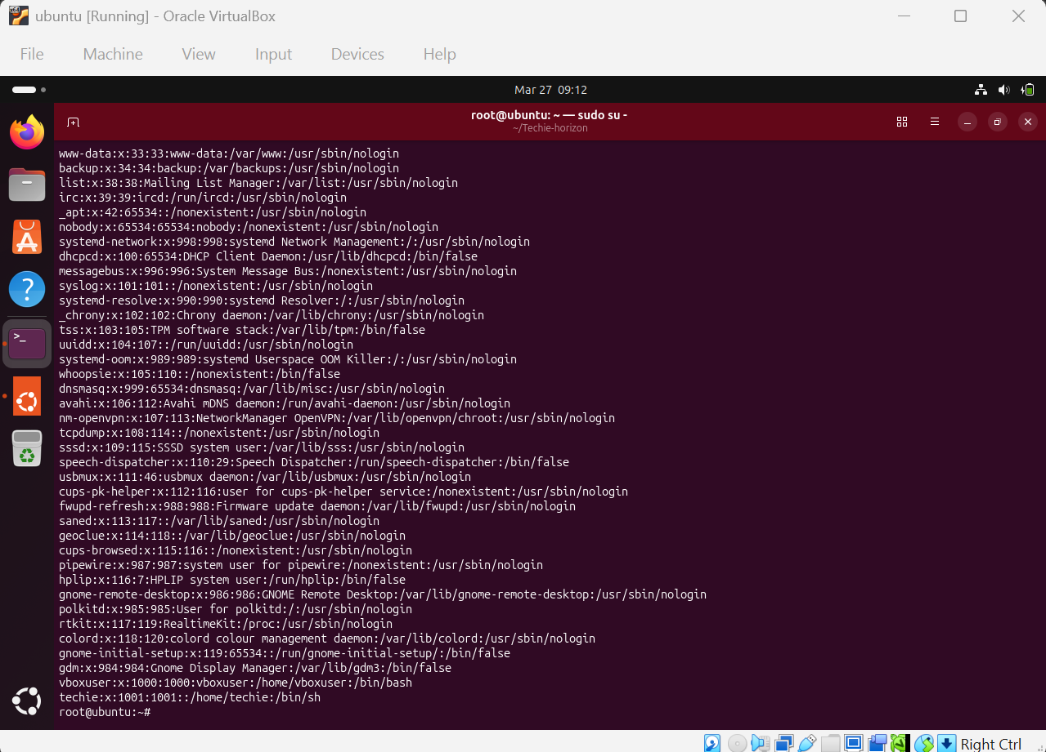
passwd to create a password
ex: passwd techie
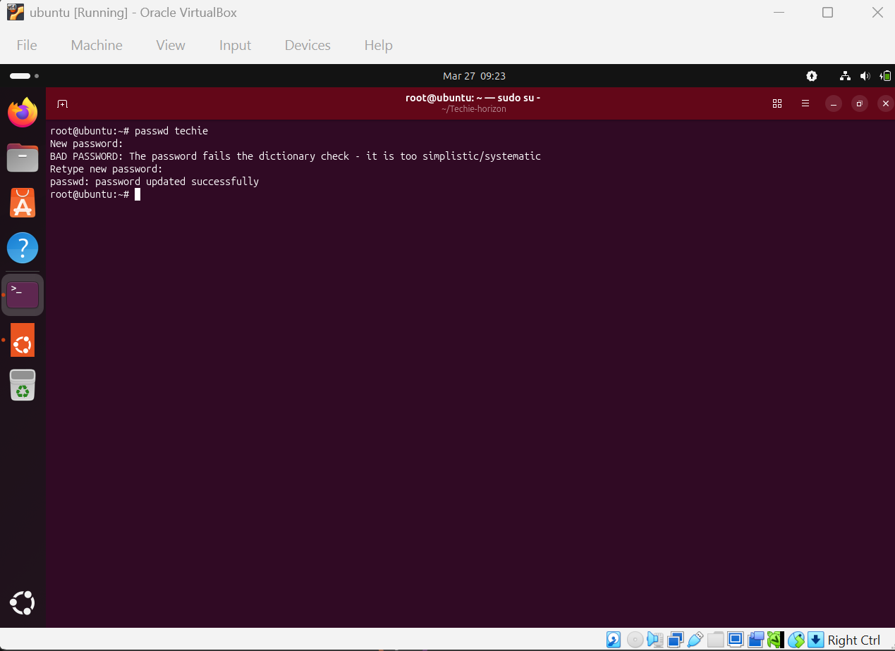
find is used for search
example: find / -name sudoers
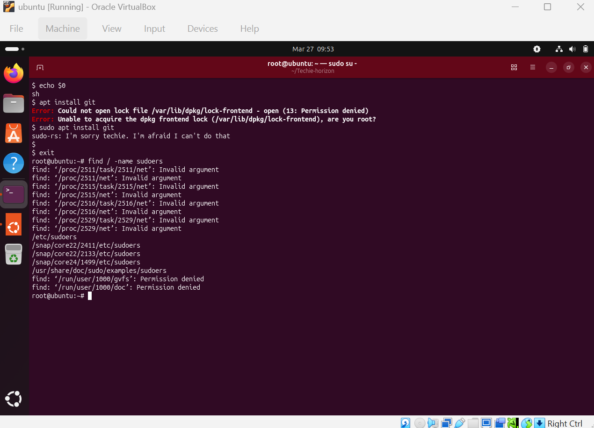
echo “hello world” > test
so that hello world is created inside the test file
with the help of > we can create the output of the file, means output will redirect the file
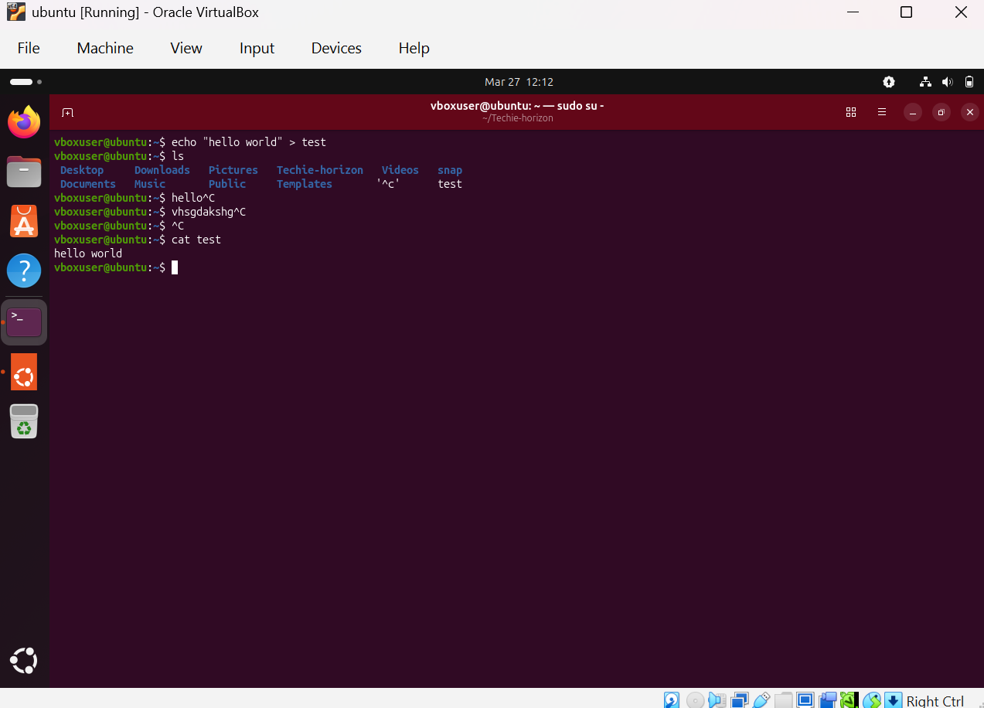
echo “techie horizon” > test
so now it will overwrite the existing content, now hello world will delete and get techie horizon
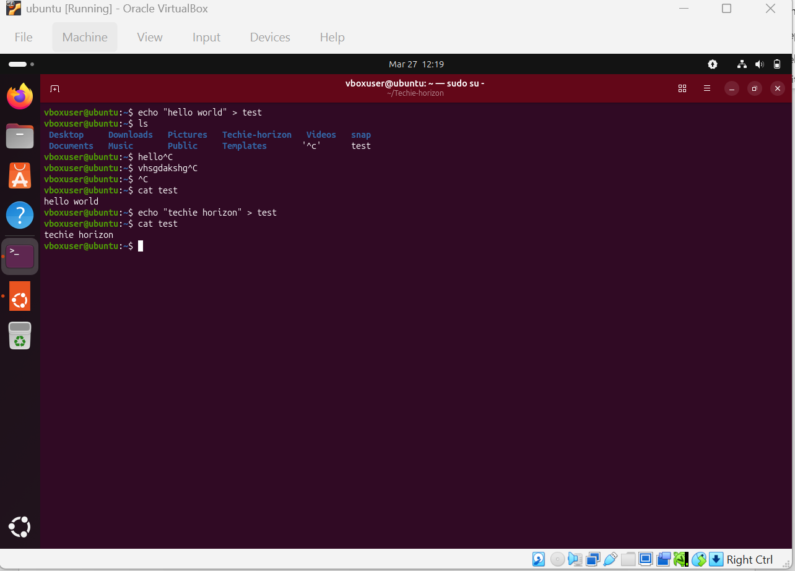
echo “hello world” >> test
so >> it will use for multiple lines as double redirection
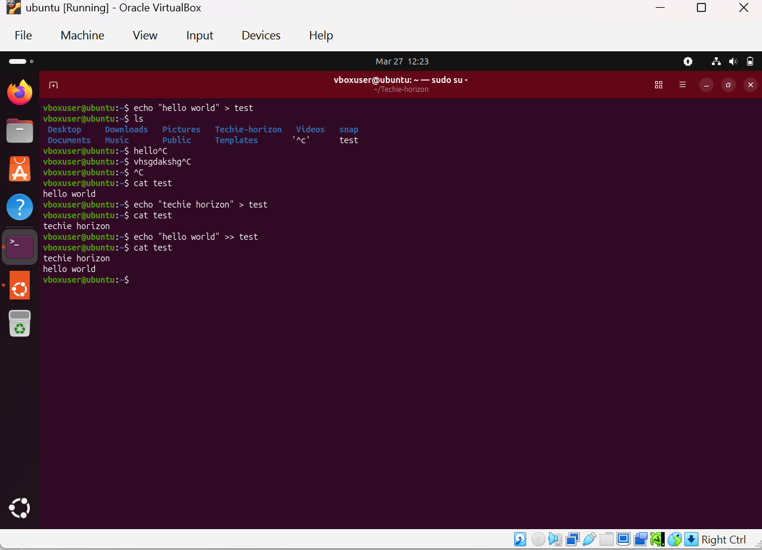
head is used for top lines of the file
tail is used for bottom lines of the file
ex: head -3 alphabet , so now it will display top 3 lines of the file
tail -3 alphabet, now it will display bottom 3 lines of the file
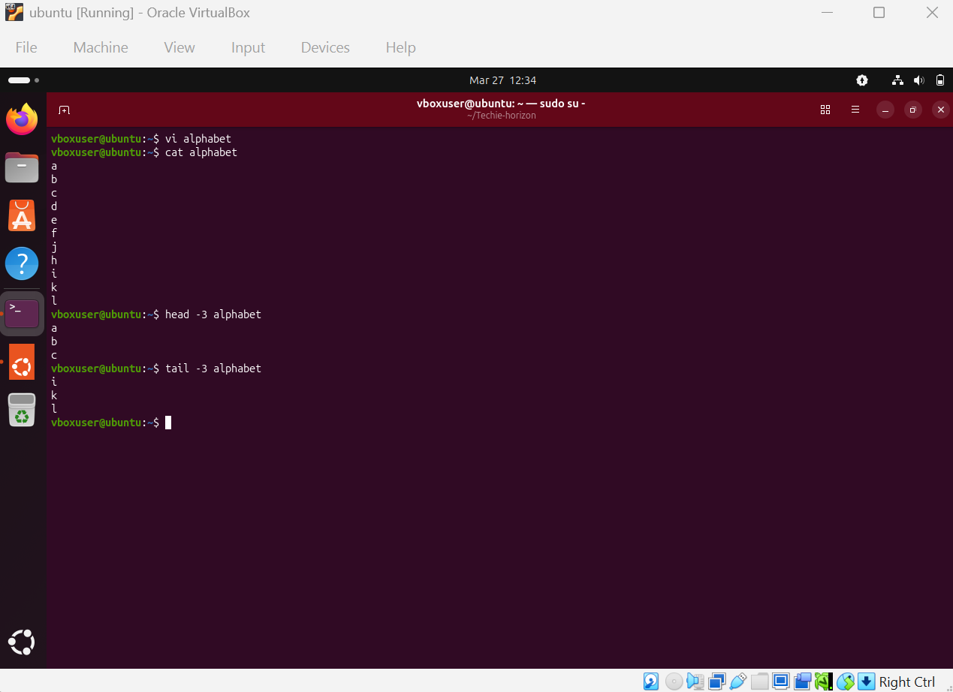
echo -f alphabet
here f will continuously monitor if you do any changes in the file
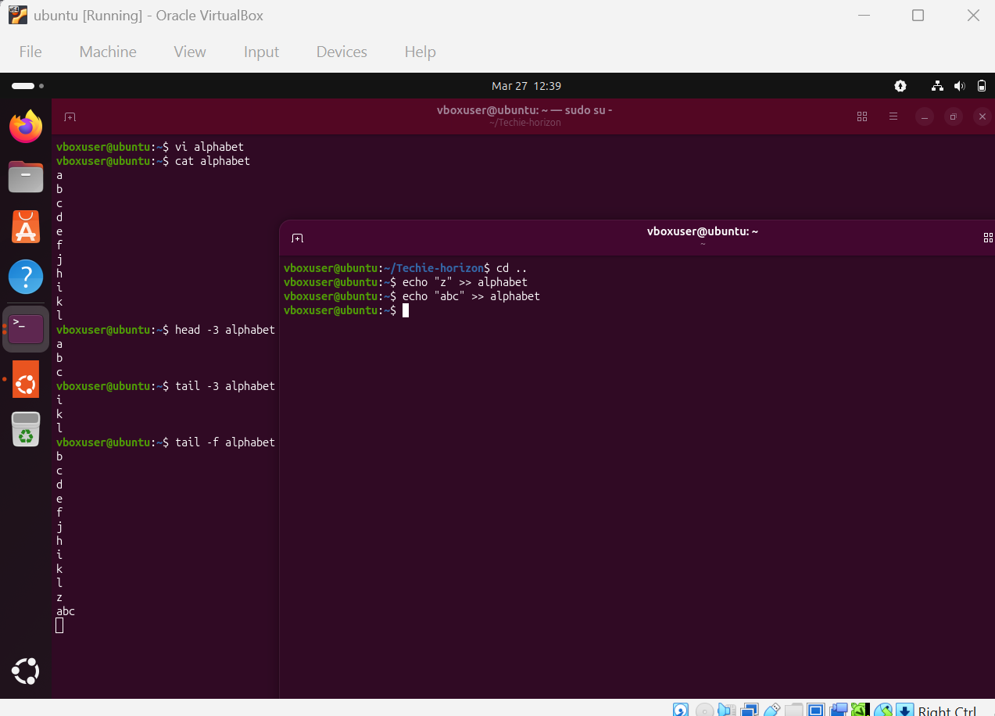
sudo find / -name *.txt
it will search the txt files
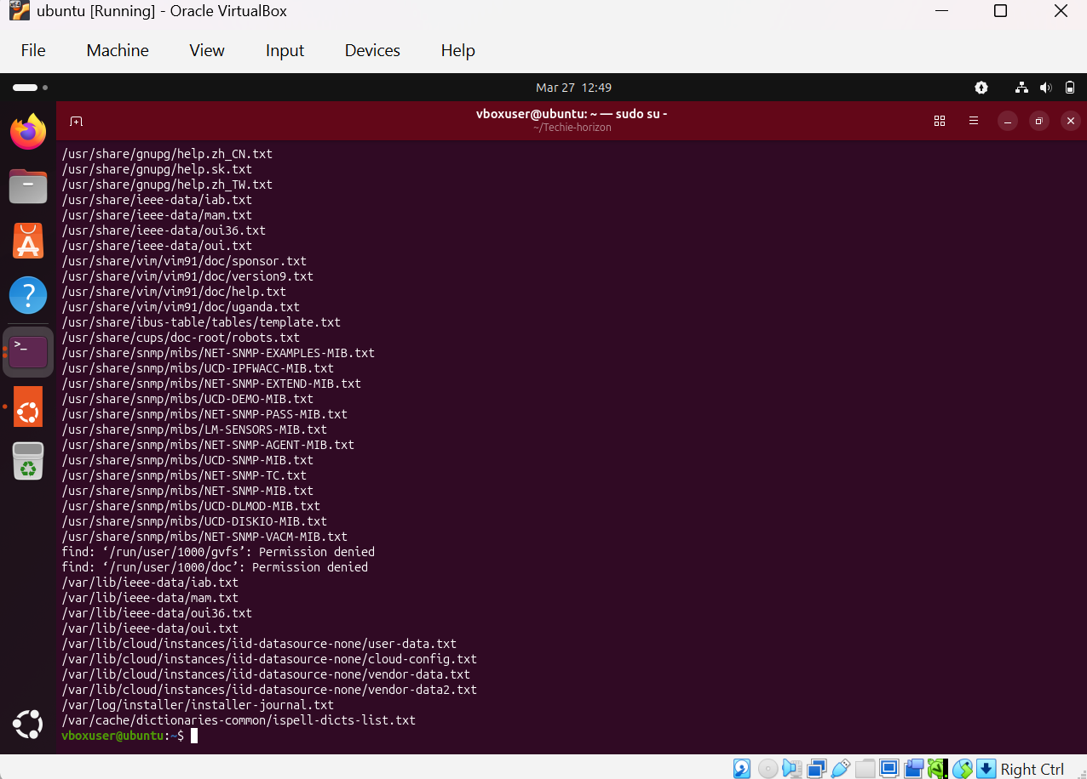
To check older than 30 days use this command
sudo find / -name sudoers -mtime +
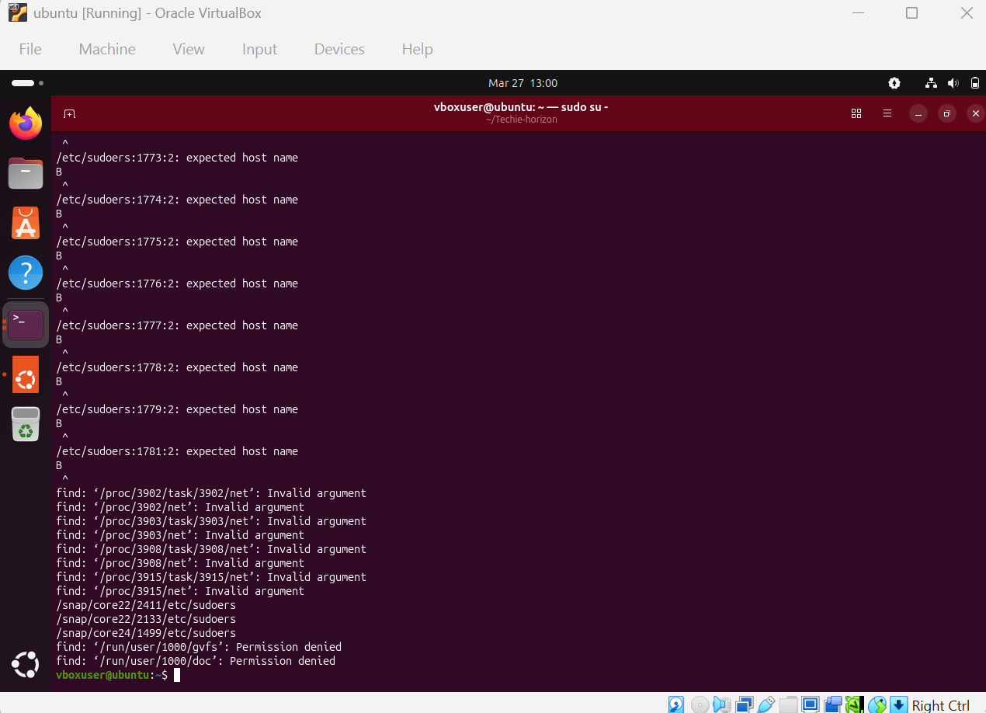
To check alphabet is there or not we can use as grep command
For example
grep z alphabet
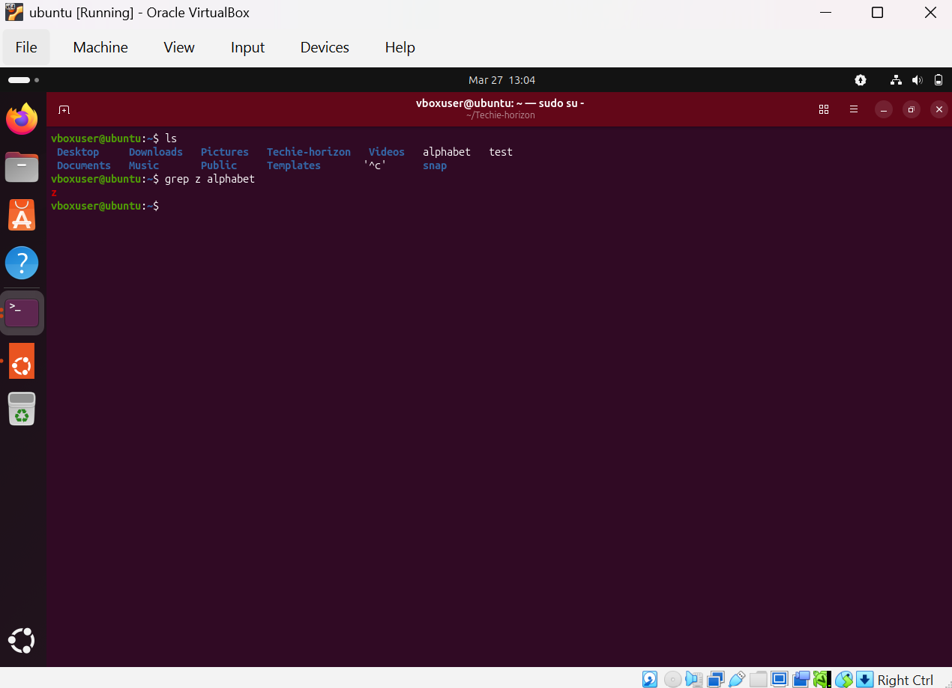
If it is not there anything then it will show as empty output
If we want to see either capital or small letter which content as recursively irrespective to the director or path, then we can use as -i
grep -i z alphabet
